# ER Time-Lapse Inversion: Sinking Plume

This tutorial reviews mesh generation and forward modeling steps presented in previous tutorials, with the objective of generating a set of synthetic time-lapse survey files that contain the data by which to image a spherical anomaly that moves downward through the subsurface. Once the synthetic survey files are generated, we use them in mode ERT4 to image the movement of the anomaly using different time-lapse inversion settings.

**Jupyter notebooks are created to divide up the task in this tutorial example**:

* The notebook *ERT2_sp.ipynb* takes the user through the forward modeling, generating the data for the baseline and time-lapse inversion.
* Two notebooks were created to take the user through the baseline *ERT3_sp_baseline,ipynb* and time-lapse inversion *ERT4_sp_timelapse.ipynb*.
* Within each directory, there is a notebook *clear_files.ipynb* which resets the directory to contain files before running any of the notebooks previously mentioned.

The forward and inversion meshes are based on those used in previous examples, and the conductivity distributions are generated using either a python script. The conceptual model for the sinking plume is shown in Figure 1. The center of the plume is located at (0,0,z) m, where z is the elevation, which starts at zero and moves downward 0.5 m at each time step. The conductivity of the plume is 0.1 S/m for r<=1, and 0.1/(r4) S/m for 1<r<2, where r is the distance from the plume centroid in meters. The background conductivity is homogeneous at 0.001 S/m.

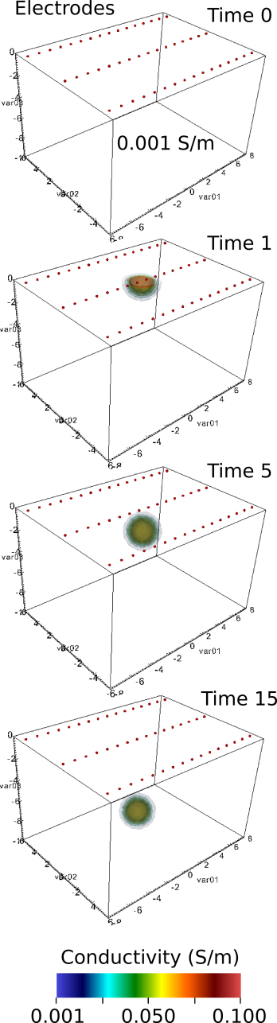

Figure 1. Conceptual model of a spherical conductivity anomaly moving downward at 0.5 m per time step in a background medium of 0.001 S/m.

## Forward Modeling

### Generating the Forward Modeling Mesh

To model the plume, we begin by generating a forward modeling mesh consisting of elements that are small enough to accurately represent plume boundaries. The mesh configuration file used to generated the forward modeling mesh is provided with the E4D distribution under *<e4d_dir>/tutorials/mode_ERT4/sinking_plume/forward/mesh/sp.cfg*. Users are encouraged to review *sp.cfg* and generate the forward modeling mesh (see mesh generation documentation for details). Zone 1 of the forward modeling mesh is shown in Figure 2. The maximum volume of elements in zone 1 is 0.01 m3 as specified in *sp.cfg*, thereby providing a highly refined mesh (>518,000 elements in this case).

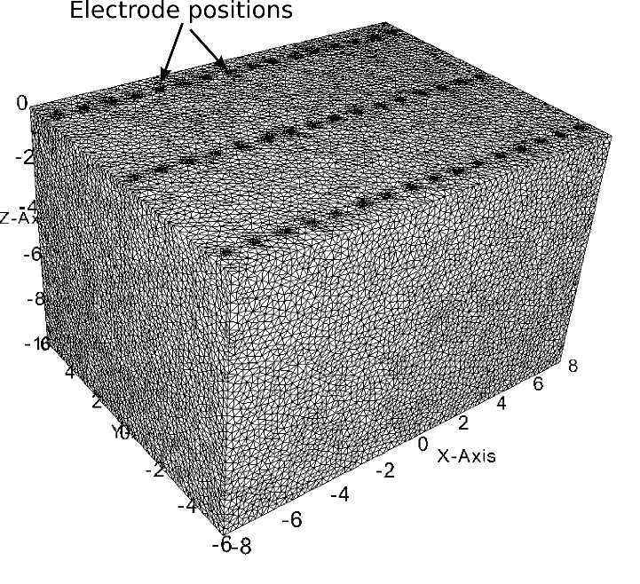

Figure 2. Zone 1 of the forward modeling mesh.

### Generating the Time-Lapse Conductivity Distributions

The time-lapse conductivity distributions are generated outside of E4D, and include a homogeneous baseline conductivity distribution and one anomalous conductivity distribution for each of the depth increments of the plume (i.e., 0 to -8 meters elevation in 0.5 m increments). The python and scilab scripts used to generate the conductivity files corresponding to each distribution are provided with the E4D distribution under *<e4d_dir>/tutorials/mode_4/sinking_plume/forward/build_conds.py and build_conds.sci*. Users are encouraged to review that script to determine how custom conductivity distributions may be generated for E4D. The basic steps include: 1) reading node and element files, 2) translating the node locations (using the translation coordinates in *.trn), 3) using the node and elements definitions to determine the centroid of each element, 4) using the element centroids to define the conductivity fields, and 4) generating the conductivity files for each conductivity field. If users choose not to execute this step, the forward mesh files are provided with the E4D distribution in a gzipped tar archive under *<e4d_dir>/tutorials/mode_ERT4/sinking_plume/forward/conductivity_files/true_sigs.tgz.* Figure 3 shows visualizations of several time steps generated using px and VisIt.

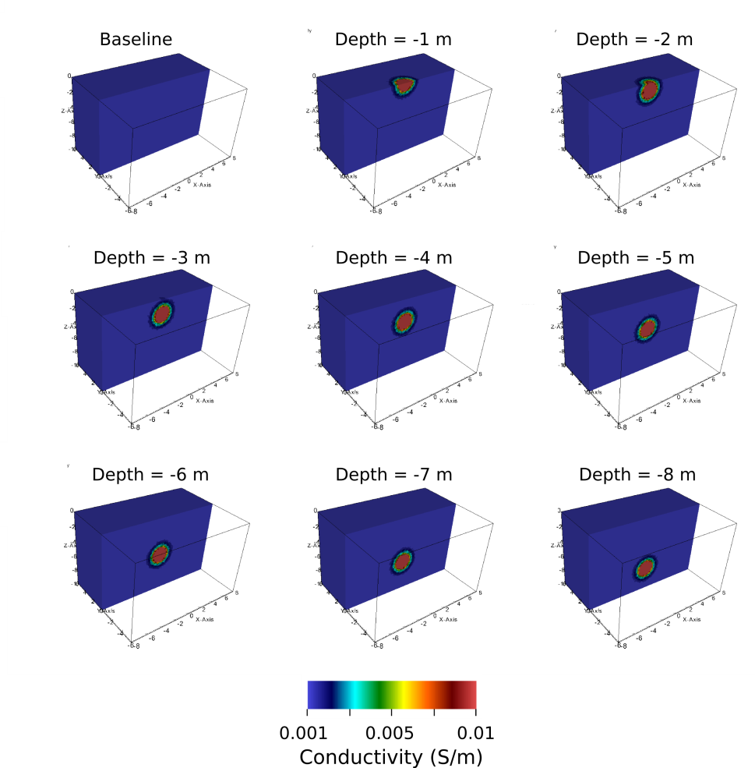

Figure 9.1. Synthetic conductivity distribution at several depths. The conductivity files were generated for the forward mesh using python to execute *build_conds.py* which is a script included with the E4D distribution.

### Synthetic Survey Generation

Synthetic survey files are generated by executing *e4d* in mode ERT2 once for each of the conductivity files. The python script discussed in the previous section generates conductivity files named *sig*.\*\*\**, where *\*.\*\*\** is the depth of the center of the plume. When *sig*.\*\*\** is specified as the conductivity file in *e4d.inp*, and *e4d* is executed in mode ERT2, *e4d* produces an output survey file named *sig*.***.srv*. This survey file contains the simulated transfer resistance measurements specified in the survey file, given the conductivity field specified in *sig*.\*\*\**. The input survey file is provided with the E4D distribution under *<e4d_dir>/tutorials/mode_ERT4/sinking_plume/forward/sp.srv.* The corresponding output survey files generated using mode ERT2 are provided in *<e4d_dir>/tutorials/mode_ERT4/sinking_plume/inverse/surveys.tgz.* Note that noise was not added to the measurements, but the standard deviations are specified as 5% of the transfer resistance magnitude plus 0.001 ohms. Although the inversion will be able to fit the data to a high tolerance in this case (i.e., a very low chi-squared value), it is set to converge at chi-squared = 1 in the inversion.

### Generating the Inversion Mesh

The inversion mesh is constructed using mode ERT1 with a survey file identical to *spf.cfg*, except that the maximum allowable volume for zone 1 is specified as 0.1 m3 instead of 0.01 m3. The mesh configuration file for the inversion mesh is included in with the E4D distribution under *<e4d_dir>/tutorial/mode_ERT4/sinking_plume/inverse/mesh/sp.cfg*. The mesh files can be found within this directory within *sp.tgz*. A visualization of zone 1 of the corresponding mesh is show in Figure 4. The mesh contains 95,387 elements in total.

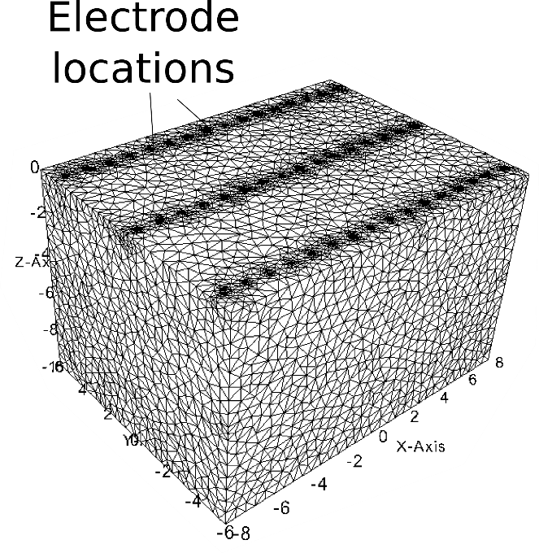

Figure 4. Zone 1 of the inversion mesh

### Baseline Inversion

The baseline conductivity distribution is homogeneous (0.001 S/m) in this tutorial. We invert the baseline survey (baseline.sig.srv) using a starting conductivity of 0.002 S/m. The *e4d.inp* and inversion options files are shown below.

**<begin file e4d.inp>** this line is not included in the file

ERT3 run mode  
sp.1.node mesh node file  
baseline.sig.srv baseline survey file  
0.002 starting conductivity value  
sp.out output options file  
sp.inv inversion options file  
none reference model file (not used … see sp.inv below)

**<end file e4d.inp>** this line is not included in the file

**<begin file sp.inv>** this line is not included in the file

2 number of constraint blocks

1 constrain zone 1 with this block  
2 1.0 1.0 1.0 use structural metric 2 (absolute difference in log conductivity between neighbors)  
1 10.0 0.15 use weighting function 1 with a large mean value to impose smoothness constraints  
1 2 apply the constraints across the boundary with zone 2

0 no reference model for this metric (this value is ignored)  
1.0 relative weight for this constraint

2 constrain zone 2 with this block  
2 1.0 1.0 1.0 use structural metric 2 (absolute difference in log conductivity between neighbors)  
1 10.0 0.15 use weighting function 1 with a large mean value to impose smoothness constraints

0 no reference model for this metric (this value is ignored)  
0 do not link to any zones (already linked to zone 1 in the block above)  
1.0 relative weight for this constraint

500 0.20 0.5 start beta at 500, decrease if obj. fnc. changes by less than 20%, decrease by 50%  
1.0 target chi-squared value  
30 50 minimum maximum number of inner iterations  
0.00001 1.0 min and max allowable conductivity  
2 no line search on beta  
1 3.0 use data culling with if the weighted residual >= 3.0 deviations from the mean

**<end file sp.inv>** this line is not included in the file

The inversion options file implements an L2 norm smoothness constrained inversion (see E4D theory guide), which is consistent with the homogeneous baseline conductivity in this case. The inversion converges in two iterations, providing the baseline conductivity distribution shown in Figure 5. Note that had we specified ‘average’ for the conductivity file in *e4d.inp*, *e4d* would have computed the average apparent conductivity and used that value as the starting value. Since the apparent conductivity of every measurement is the true conductivity in this case, the data would have been fit exactly at the starting model and no inversion would have been executed.

Although the baseline inversion results are nearly homogeneous at the true value of 0.001 S/m, there is obviously some heterogeneity. Because the homogeneous model constraints are perfectly consistent with the data in this case, a perfectly recovered homogeneous model might have been expected . Such results may be possible by increasing the starting beta value, thereby forcing the inversion to better honor the smoothness constraints. The data lose sensitivity to the conductivity distribution below about -6 m elevation, as evidenced by the upward trend in conductivity toward the starting model of 0.002 S/m. This loss in resolution at greater depths will also be evident in the time-lapse inversion results.

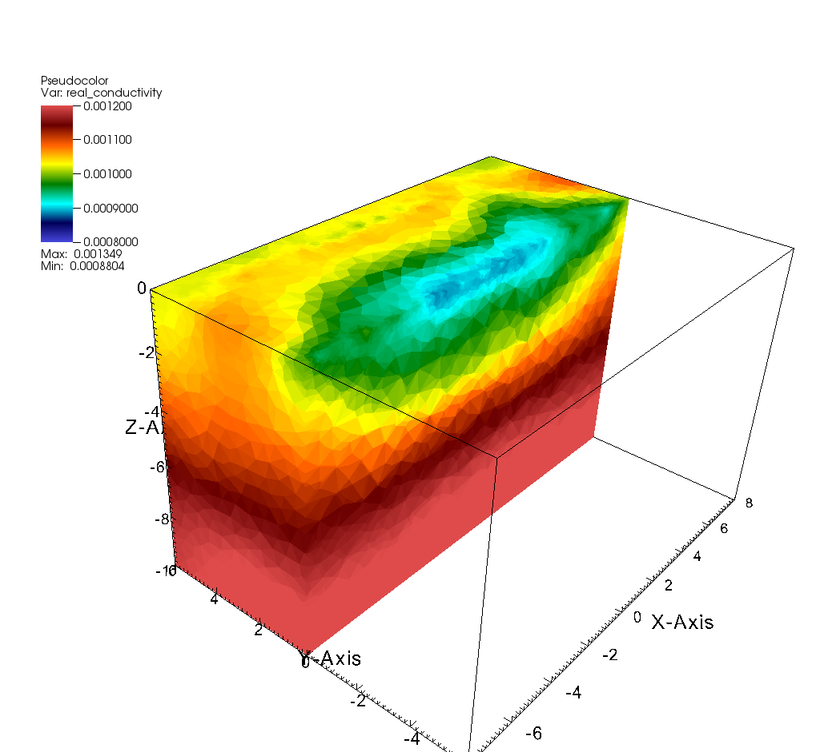

Figure 5. Baseline inversion conductivities range from approximately 0.0008 to 0.0012 S/m, bounding the true conductivity of 0.001 S/m.

## Time-Lapse Inversions Using the Baseline Solution as Reference

In this tutorial, we demonstrate two time-lapse inversions using time-lapse smoothness constraints. In this section, we use the baseline solutions as a reference model for each time solution. In the next section, we use the previous time-lapse solution as the reference model. To investigate other options, we encourage users to modify these examples to include other constraints, such as maximum and minimum conductivity bounds, blocky time-lapse constraints, known value constraints, etc. For example, similar to the static inversions, blocky time-lapse constraints can be implemented by simply decreasing the mean of the weighting function in each of the examples shown below. The inversions execute relatively quickly and are informative concerning the effects of different constraining conditions. It is also informative to plot the intermediate solutions and interpret in conjunction with the log file. The conductivity solution files associated with using the baseline solution as a reference can be found in *<e4d_dir>/tutorials/mode_ERT4/sinking_plume/inverse/time_lapse/inv_baseline.tar.gz.*

When constraining a time-lapse inversion to use the baseline solution as reference, it is generally recommended to use *up_opt = 2* in the inversion options file, which enables *e4d* to reduce the beta value when necessary. This is particularly important if the time-lapse solutions are expected to change significantly from the baseline solution. The input options file and inversion options file shown below illustrate the basic settings that can be used for a time-lapse inversion that is constrained using a baseline solution reference model. Note the baseline solution conductivity file in Figure 5 is named *baseline_sp.sig* in *e4d.inp,* as shown below. The inversion options file is name *sp_tl.inv*, and the survey list file is named *surveys.txt*. Each of these files is included with the E4D distribution under *<e4d_dir>/tutorials/mode_4/sinking_plume/inverse/time_lapse/* .

**<begin file e4d.inp>** this line is not included in the file

4 run mode  
sp.1.node mesh node file  
baseline.sig.srv baseline survey file  
baseline_sp.sig starting conductivity value  
sp.out output options file  
sp_tl.inv inversion options file  
baseline_sp.sig reference model file   
surveys.txt 1 survey list file, using baseline model as starting model

**<end file e4d.inp>** this line is not included in the file

**<begin file sp_tl.inv>** this line is not included in the file

2 number of constraint blocks

1 constrain zone 1 with this block  
8 1.0 1.0 1.0 use structural metric 8 (spatial difference of temporal differences)  
1 10.0 0.15 use weighting function 1 with a large mean value to impose smoothness constraints  
1 2 apply the constraints across the boundary with zone 2

‘ref’ use reference model specified in *e4d.inp* as reference   
1.0 relative weight for this constraint

2 constrain zone 2 with this block  
8 1.0 1.0 1.0 use structural metric 8   
1 10.0 0.15 use weighting function 1 with a large mean value to impose smoothness constraints  
0 do not link to any zones (already linked to zone 1 in the block above)

‘ref’ use reference model specified in *e4d.inp* as reference  
1.0 relative weight for this constraint

200 0.05 0.5 start beta at 500, decrease if obj. fnc. changes by less than 20%, decrease by 50%  
1.0 target chi-squared value  
30 50 minimum maximum number of inner iterations  
0.00001 1.0 min and max allowable conductivity  
2 no line search on beta, reduce beta as needed  
1 3.0 use data culling with if the weighted residual >= 3.0 deviations from the mean

**<end file sp_tl.inv>** this line is not included in the file

**<begin file surveys.txt>** this line is not included in the file

21 number of time-lapse survey files  
sig_0.sig.srv 0.0 first survey file and time stamp  
sig_0.5.sig.srv 0.5 second survey file and time stamp  
sig_1.sig.srv 1.0 third survey file and time stamp  
.  
.  
.  
sig_10.sig.srv 10 21st and final survey file and time stamp

**<end file surveys.txt>** this line is not included in the file

The inversion is executed as normal, and requires from 9 to 12 iterations for convergence for each time-lapse solution with these settings when the plume is within the resolved zone. As will be shown, the inversion requires from 1 to 3 iterations per solution when using the previous solution as the reference. This is because the previous solution is generally closer to the true solution than the baseline solution. However, using the baseline solution enables some useful constraints that are not available when the previous solution is used. For example, induced tracer tests often involve conductive tracers, and it can be assumed that the subsurface conductivity is always greater than or equal to the baseline conductivity. Therefore, a constraint can be implemented that encourages the time-lapse conductivity distribution to be everywhere greater than the baseline conductivity distribution for each inversion. Note that, although it is not demonstrated in this tutorial, it is possible to use both the reference model and previous model to constrain the inversion using separate constraint blocks.

A selected set of the time-lapse solutions generated using the settings above is shown in Figure 6 in comparison to the true solutions and the previous model reference solutions discussed in the next section.

## Time-Lapse Inversions Using the Previous Solution as Reference

The file modification necessary to run the inversion using the previous solution as the reference model for each time-lapse inversion are shown below. In this case each time-lapse solution converges in one to three iterations. Results are shown in comparison to the true model and the inversion executed in section 9.2. Note that the results using the previous model as reference show the ‘shadow’ of the previous inversion. This happens when the plume moves below the depth where it is sensitive to the data (about 4-5 m depth), whereby changes in the data are insufficient to resolve changes in the conductivity distribution from the previous solution (which is also the starting model). The conductivity solution files associated with using the previous solution as a reference can be found in *<e4d_dir>/tutorials/mode_ERT4/sinking_plume/inverse/time_lapse/inv_previous.tar.gz.*

Users are encouraged to experiment with these inversions by, for example, adding a positivity constraint to the change in conductivity with respect to baseline (e.g. structural metric 3, weighting function 1 with zero mean and the baseline solution as reference).

**<begin file e4d.inp>** this line is not included in the file

4 run mode  
sp.1.node mesh node file  
baseline.sig.srv baseline survey file  
baseline_sp.sig starting conductivity value  
sp.out output options file  
sp_tl.inv inversion options file  
baseline_sp.sig reference model file   
surveys.txt 2 survey list file, using previous model as the starting model

**<end file e4d.inp>** this line is not included in the file

**<begin file sp_tl.inv>** this line is not included in the file

2 number of constraint blocks

1 constrain zone 1 with this block  
8 1.0 1.0 1.0 use structural metric 8 (spatial difference of temporal differences)  
1 10.0 0.15 use weighting function 1 with a large mean value to impose smoothness constraints  
1 2 apply the constraints across the boundary with zone 2

‘pref’ use the previous solution as reference  
1.0 relative weight for this constraint

2 constrain zone 2 with this block  
8 1.0 1.0 1.0 use structural metric 8   
1 10.0 0.15 use weighting function 1 with a large mean value to impose smoothness constraints  
0 do not link to any zones (already linked to zone 1 in the block above)

‘pref’ use the previous solution as reference  
1.0 relative weight for this constraint

100 0.05 0.5 start beta at 100, converge if change in obj. function <= 5% (since up_opt =3 below)  
1.0 target chi-squared value  
30 50 minimum maximum number of inner iterations  
0.00001 1.0 min and max allowable conductivity  
3 do not reduce beta  
1 3.0 use data culling with if the weighted residual >= 3.0 deviations from the mean

**<end file sp_tl.inv>** this line is not included in the file

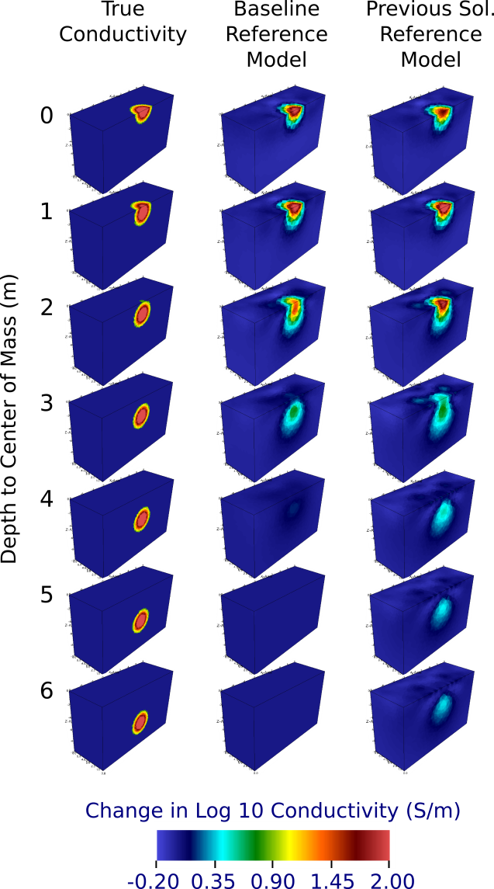

Figure 6. Comparison between true conductivity and imaged conductivity using the baseline solution and previous solutions as the reference model with transient smoothing constraints (structural metric 8).